# Peer-graded Assignment: 2.4.3 Team assignment. Part 1

Group 7, Team 4: Tanner Mood, Donato Scarano, Petra Vujakovic, Yatharth Khatri

## Objectives:

* Identification of purpose of web site to the appropriate stakeholders
* Evidence and analysis of 5 theme park web sites
* Identification of relevant and appropriate content for the web site
* Identification of an appropriate structure for the pages for the content for this web site
* Design of the wireframes as a clear model for the web site

-TM

## ****Agree on the purpose of the website****

*Discuss the reasons for a theme park operator to have a web site, the people who might look at such a web site and the reasons that they would be looking at the web site.*

Reasons for a website are:

* Visibility and advertisement
* Up-to-date information on new attractions and events
* Online ticket selling (up-front revenue stream and ease of business)
* Analytics and metrics (identify trends within their customer base and understand their customers better identifying interaction and navigation patterns).
* Social media interaction and amplification (Twitter, Facebook, Instagram… integrations)
* Groups and Events schedules and management

People who look at the website:

* Families
* Groups
* Individuals

Reason they look at the website for:

* Up-to-date information on events and schedules
* Purchase ticket conveniently in advance without queues
* Status of attractions and detailed descriptions
* Plan their visit in advance with interactive maps and guides
* Contacts and location directions
* Social media experiences and reviews
* Facilities for families and groups

TM – I’m not sure interactive maps are in our design budget

## ****Research theme park web sites****

*As a group, choose five different web sites of theme parks. Review the type of information that you find on the sites, and the structure that these sites have to help people find that information. Make a list of the aspects of the sites that you think are a good idea or that work well, and a list of the aspects of the sites that you don't think are so successful. This will give you some insights that you can use when designing your own web site. Keep a record of the discussion in a document.*

DS Websites proposed are:

<https://www.oakwoodthemepark.co.uk>

<https://www.altontowers.com>

<https://www.draytonmanor.co.uk>

<https://www.thorpepark.com>

<https://www.europapark.de/en>

PV:

1. Navigation bars – most websites observed seem to have more than 1 navigation bar. One for descriptions of attractions and services in the park, and a separate navigation bar for administrative info (tickets, prices, search bar). Though it may be more straightforward to just have one navigation bar.
2. TICKETS – this is an important element, and most websites seem to have a button or a direct reservation link on the homepage. Even if general info on tickets and opening hours is also repeated in a separate page.
3. Big promotion – homepage often has a big promotion of an attraction, or seasonal ticket.
4. Group activities – many parks seem to have a special page for schools / group visitors, as such guests need more advanced planning of their visit
5. Food & accommodation – navigation bar often has a separate link to facilities and

services for daytrips and longer stays.

1. Park opening and Closing times is something else they all have in common, Europa also has real time weather which I think is a nice touch. - TM

## ****Agree on the content for the web site****

*Agree within the group the theme for your theme park and the types of attractions that you will have for the different visitors that you expect to come to your theme park. Think of any other services that you will provide to visitors (for example food, access to money and medical help). Think of any other information that people looking at your web site will want to know before they come and visit your theme park. Keep a record of the discussion in a document.*

Theme to agree:

DS: Ferrari theme Park in Abu Dhabi proposed by Petra sounds interesting to me.

PV: I think we have to come up with a new theme? If we can copy it, sure. Otherwise, we could do something similar, maybe oldtimer cars, or space travel (not that similar, haha, but I think it’s easy to come up with ideas for activities – “eat like astronaut”, “zero gravity chamber”, “rocket roller coaster”, “virtual reality on moon”…. )

TM – Space is good, I think we can work with that.

DS – Space theme sound great.

Services to provide:

DS: Ticketing services, food and accommodation, group activities, promotions, special needs, maps and directions, financial services

## ****Agree on the structure of the web site****

*Agree within your group the structure of your web site, with the aim of designing a web site with 3 pages. What information will appear on the main page, and what will appear on the other two pages. Think about how you might present the content, and whether you will have semantic parts such as asides or pop-up windows. Keep a record of the discussion in a document.*

DS: Main Page (welcome, navigation hub and site map, fancy and eye catching to entice usage and discovery, highlights of the day)

PV: Agree, so to summarize, main page should have:

* Navigation bar
  + Link to other 2 pages
  + Search bar
  + Link to footer with info
* Name of the theme park (“Space Park / Car Park”)
* Promotion advertisement (“Summer pass / Summer Space Camp”) with a button link to purchase tickets
* Footer with important links to info (opening hours, contact, location)

TM – Top Right corner should have a “Purchase tickets here” button on all pages

DS: 1st Page: Map of the theme park and description of every attraction with detailed info and media

PV: I think a map would be great, but not sure if it’ll be too much work? Otherwise we can list activities: all the fun stuff, rides, movies, fireworks, maybe even restaurants, and with some fun pictures.

TM – I can put together a simple map as a picture file

DS – simple will do even a picture or a google map link will be fine.

DS: 2nd page: Reservation site to book entry, extra attractions lodging, restaurants and more

PV: If I understand DS idea correctly, first page was more about selling the fun (what can you do at the park), this page would be more informational, how you buy the fun: book accommodation, reserve restaurants for birthday parties, educational programs for school-trips. You can get to this page both through Navigation, and the “Book Now” buttons from every page/attraction. (?)

DS Sounds good.

## ****Design the wireframes for the web site****

*Produce a set of wireframes for the site, showing the concepts for both a wide screen and small screen. These can either be drawn by hand or produced using a tool such as PowerPoint or a graphics package such as Illustrator. Avoid painting or photo-editing software such as Paint or Photoshop as designs produced in this way are difficult to edit. Ensure that the designs are clear and easy to read.*

*DS WIREFRAME:*

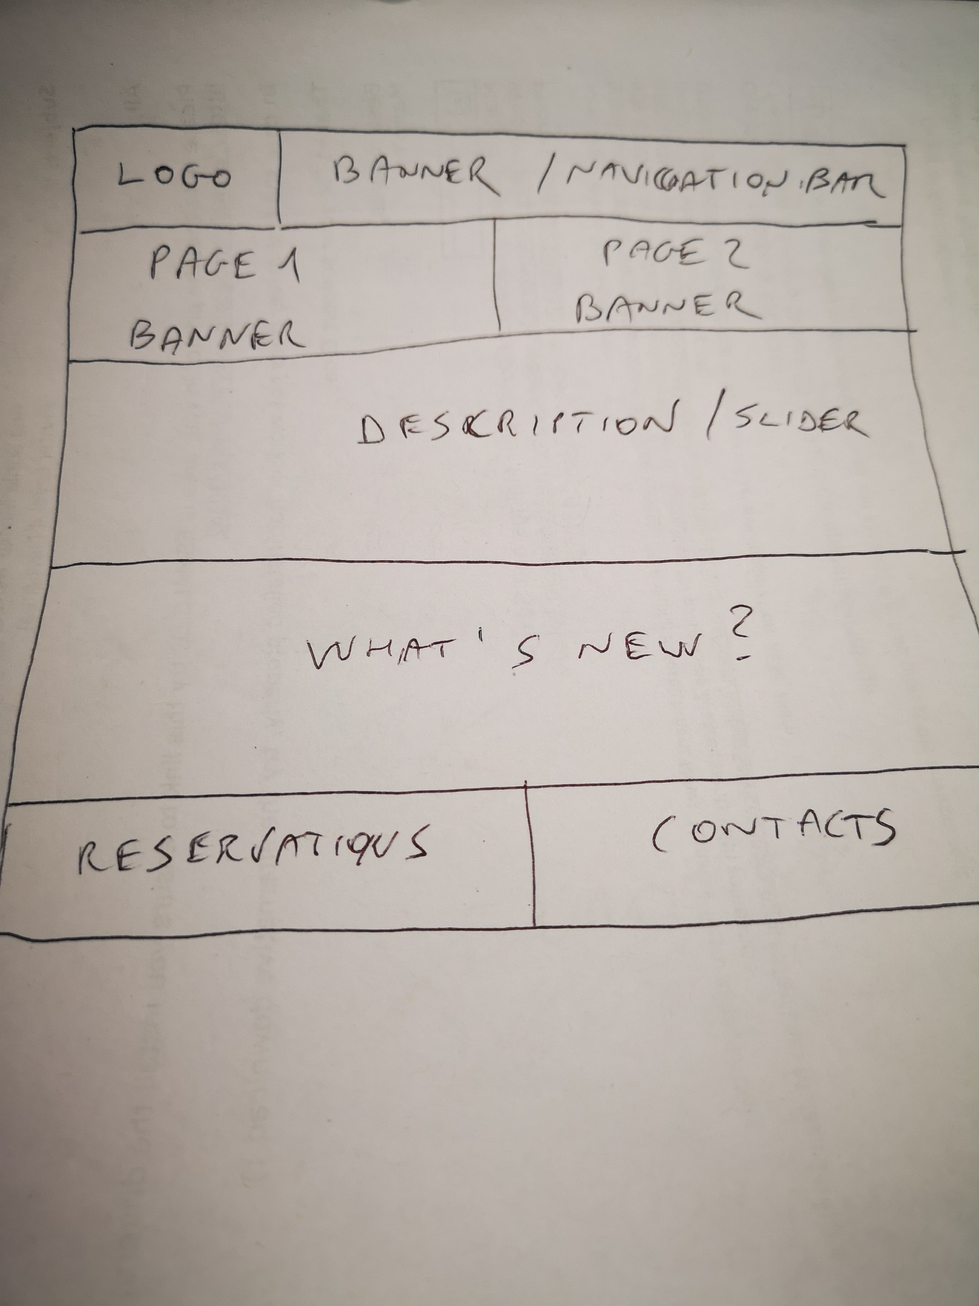

PV: Building on what DS started, here are more detailed wireframes for all 3 pages, each photo has the DESKTOP version on the left, and a MOBILE version on the right.

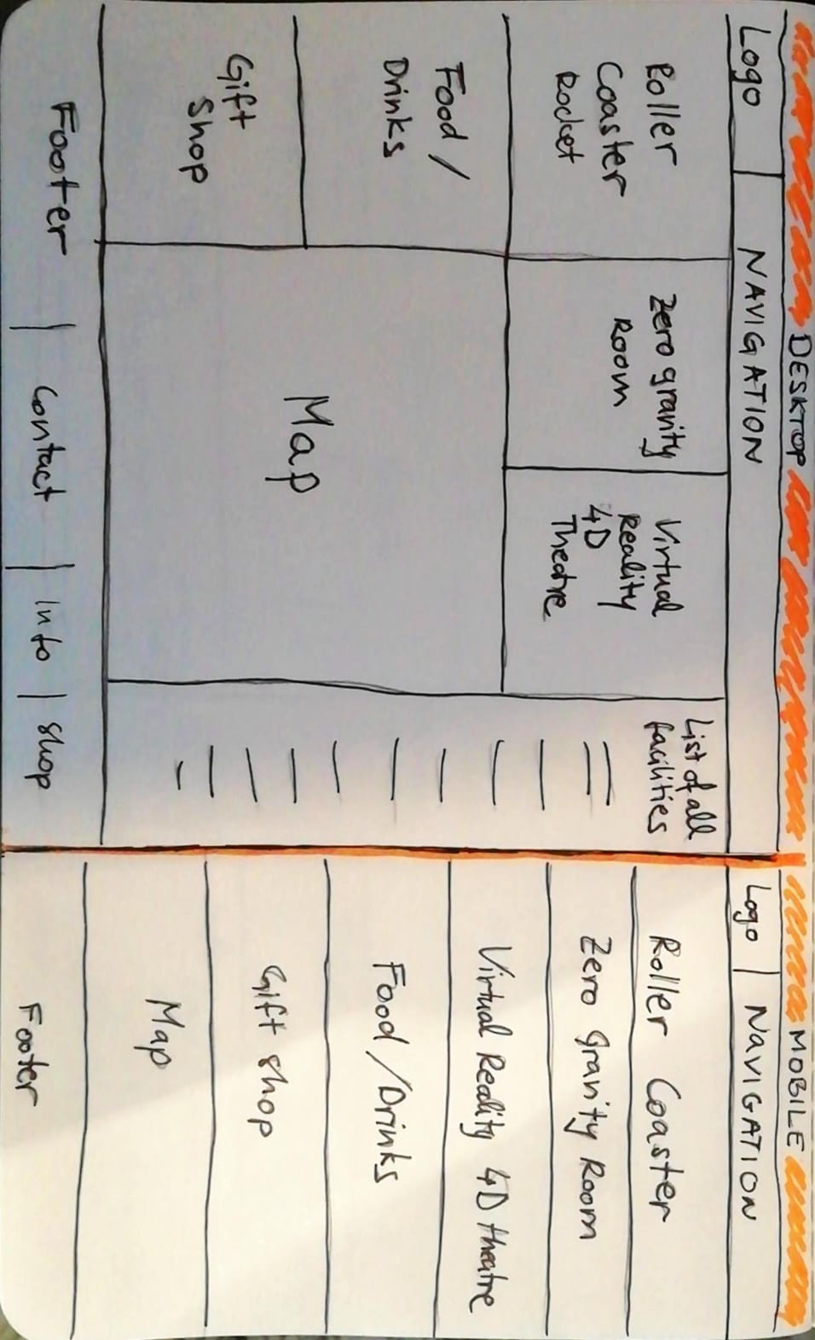

**HOME PAGE**

**PAGE 1**

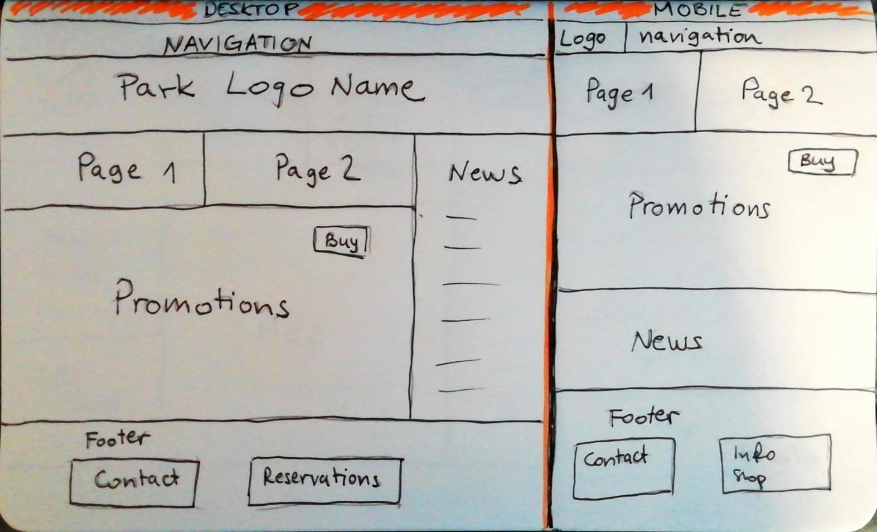

**PAGE 2**

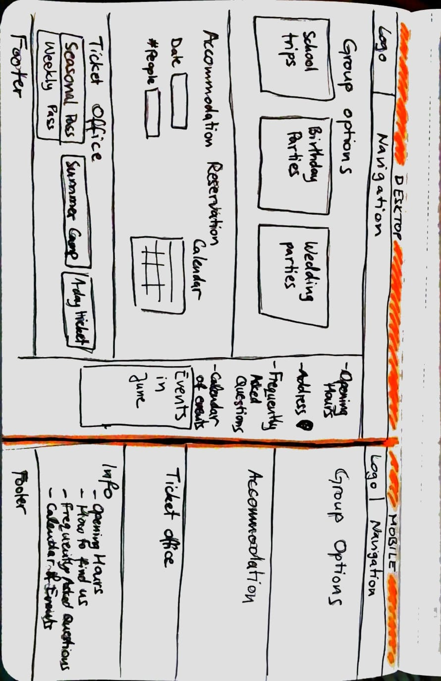

TM- looks good but id suggest we make the mobile site really long so we can fit all the same information in, people are good with scrolling on their phones.

PV: Yes, agreed – the mobile page should be longer, I just didn’t have space on the paper to scroll down, so I “compressed” it for the wireframe.

DS: good job